PROJECT PLAN
Conflict Intelligence
Timeline, who does what, deliverables, coverage and resources
PROGRAM  DEPI – Data Analyst Track | ROUND  MIN5_DATA3_S1 | PROJECT DURATION  5 Oct – 4 Dec 2026
1 Timeline (Gantt Chart)
The project runs from 5 October to 4 December 2026 with 63 tasks. Each member has his or her own block below; bar colour shows the owner and the dashed red lines are the official deadlines. The editable version is the Excel file Gantt_Chart.xlsx (sheets: Gantt Chart, By Person, Weekly Plan).
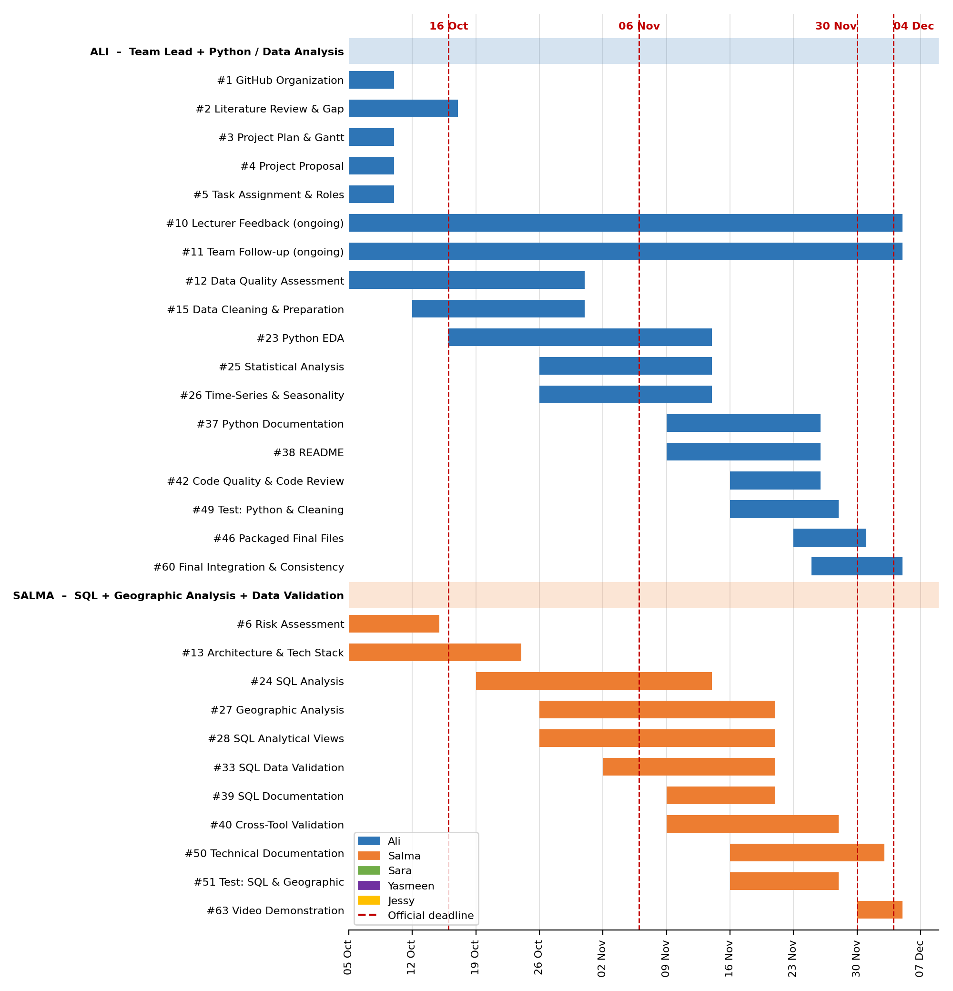
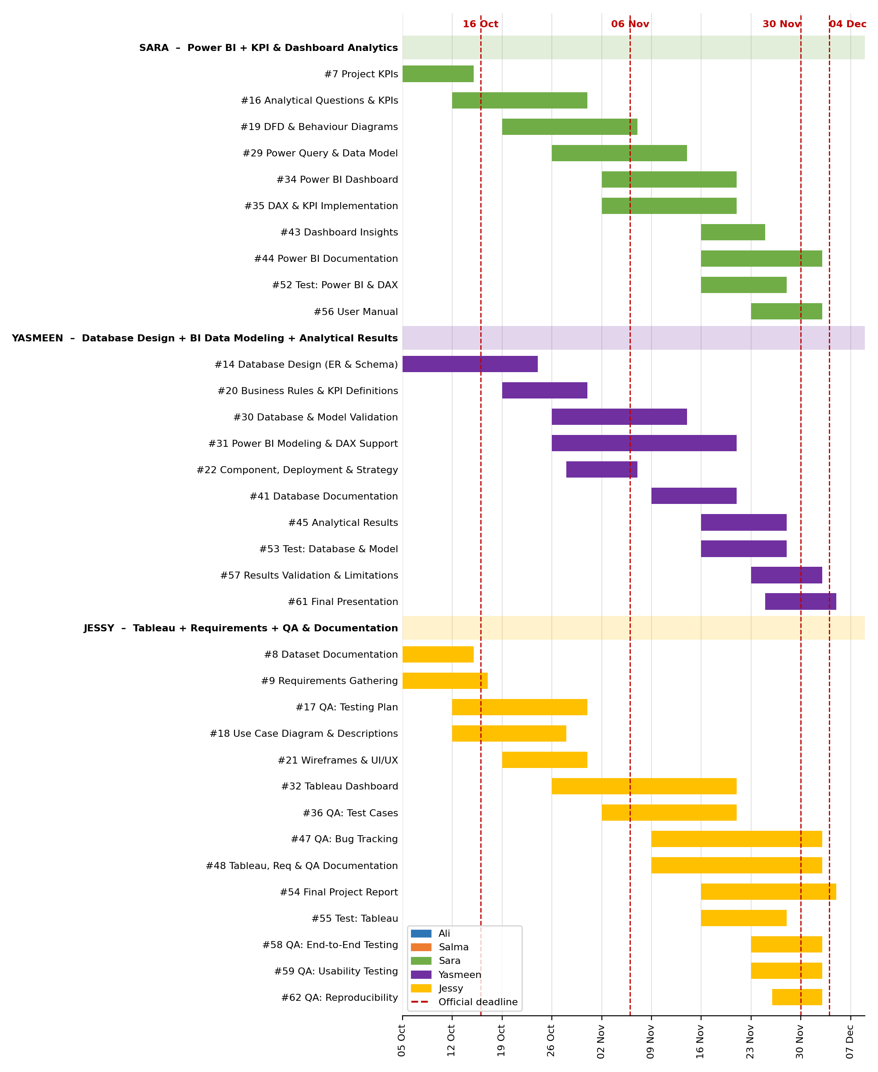
2 Who Does What
Each member owns the tasks below from start to finish.
Member | Main role | Tasks (number in the Gantt chart, dates)
Ali | Team Lead + Python / Data Analysis | #1 GitHub Organization (5 Oct – 9 Oct)  #2 Literature Review & Gap (5 Oct – 16 Oct)  #3 Project Plan & Gantt (5 Oct – 9 Oct)  #4 Project Proposal (5 Oct – 9 Oct)  #5 Task Assignment & Roles (5 Oct – 9 Oct)  #10 Lecturer Feedback (ongoing) (5 Oct – 4 Dec)  #11 Team Follow-up (ongoing) (5 Oct – 4 Dec)  #12 Data Quality Assessment (5 Oct – 30 Oct)  #15 Data Cleaning & Preparation (12 Oct – 30 Oct)  #23 Python EDA (16 Oct – 13 Nov)  #25 Statistical Analysis (26 Oct – 13 Nov)  #26 Time-Series & Seasonality (26 Oct – 13 Nov)  #37 Python Documentation (9 Nov – 25 Nov)  #38 README (9 Nov – 25 Nov)  #42 Code Quality & Code Review (16 Nov – 25 Nov)  #49 Test: Python & Cleaning (16 Nov – 27 Nov)  #46 Packaged Final Files (23 Nov – 30 Nov)  #60 Final Integration & Consistency (25 Nov – 4 Dec)
Salma | SQL + Geographic Analysis + Data Validation | #6 Risk Assessment (5 Oct – 14 Oct)  #13 Architecture & Tech Stack (5 Oct – 23 Oct)  #24 SQL Analysis (19 Oct – 13 Nov)  #27 Geographic Analysis (26 Oct – 20 Nov)  #28 SQL Analytical Views (26 Oct – 20 Nov)  #33 SQL Data Validation (2 Nov – 20 Nov)  #39 SQL Documentation (9 Nov – 20 Nov)  #40 Cross-Tool Validation (9 Nov – 27 Nov)  #50 Technical Documentation (16 Nov – 2 Dec)  #51 Test: SQL & Geographic (16 Nov – 27 Nov)  #63 Video Demonstration (30 Nov – 4 Dec)
Sara | Power BI + KPI & Dashboard Analytics | #7 Project KPIs (5 Oct – 14 Oct)  #16 Analytical Questions & KPIs (12 Oct – 30 Oct)  #19 DFD & Behaviour Diagrams (19 Oct – 6 Nov)  #29 Power Query & Data Model (26 Oct – 13 Nov)  #34 Power BI Dashboard (2 Nov – 20 Nov)  #35 DAX & KPI Implementation (2 Nov – 20 Nov)  #43 Dashboard Insights (16 Nov – 24 Nov)  #44 Power BI Documentation (16 Nov – 2 Dec)  #52 Test: Power BI & DAX (16 Nov – 27 Nov)  #56 User Manual (23 Nov – 2 Dec)
Yasmeen | Database Design + BI Data Modeling + Analytical Results | #14 Database Design (ER & Schema) (5 Oct – 23 Oct)  #20 Business Rules & KPI Definitions (19 Oct – 30 Oct)  #30 Database & Model Validation (26 Oct – 13 Nov)  #31 Power BI Modeling & DAX Support (26 Oct – 20 Nov)  #22 Component, Deployment & Strategy (28 Oct – 6 Nov)  #41 Database Documentation (9 Nov – 20 Nov)  #45 Analytical Results (16 Nov – 27 Nov)  #53 Test: Database & Model (16 Nov – 27 Nov)  #57 Results Validation & Limitations (23 Nov – 2 Dec)  #61 Final Presentation (25 Nov – 4 Dec)
Jessy | Tableau + Requirements + QA & Documentation | #8 Dataset Documentation (5 Oct – 14 Oct)  #9 Requirements Gathering (5 Oct – 16 Oct)  #17 QA: Testing Plan (12 Oct – 30 Oct)  #18 Use Case Diagram & Descriptions (12 Oct – 27 Oct)  #21 Wireframes & UI/UX (19 Oct – 30 Oct)  #32 Tableau Dashboard (26 Oct – 20 Nov)  #36 QA: Test Cases (2 Nov – 20 Nov)  #47 QA: Bug Tracking (9 Nov – 2 Dec)  #48 Tableau, Req & QA Documentation (9 Nov – 2 Dec)  #54 Final Project Report (16 Nov – 4 Dec)  #55 Test: Tableau (16 Nov – 27 Nov)  #58 QA: End-to-End Testing (23 Nov – 2 Dec)  #59 QA: Usability Testing (23 Nov – 2 Dec)  #62 QA: Reproducibility (26 Nov – 2 Dec)

3 Cross-Team Responsibilities
Some work is shared. In each case one person leads and the others contribute from their own area.
Responsibility | Lead | Who contributes | Output
Analytical Questions & KPIs | Sara | Whole team contributes questions for its technical area. Yasmeen turns the shortlist into Business Rules & KPI Definitions. | Question list and KPI definitions (examples: trends over time, most affected countries / regions, conflict duration, fatalities, civilian impact, geographic concentration, violence types, parties involved)
Insights, Recommendations & Limitations | Yasmeen (consolidation) | Ali: Python / statistical findings. Salma: SQL / geographic findings. Sara: Power BI / dashboard insights. Jessy: Tableau / QA evidence. | Key insights, evidence, recommendations, limitations, future analysis
Cross-Tool Validation | Salma | Every member validates his or her own tool. | SQL = Python = Power BI = Tableau for total events, total fatalities, yearly trends, country / region counts, major KPIs and key results. Each discrepancy is identified, investigated, explained, then corrected or documented
Testing & QA | Jessy | Each member tests his or her own area: Ali: Python, data quality, cleaning. Salma: SQL, geographic analysis. Sara: Power BI, DAX, dashboard. Yasmeen: database, data model. Jessy: Tableau, end-to-end, reproducibility. | Test plan, test cases, results, bug log with resolutions
Documentation | Jessy (structure only) | SQL: Salma. Python: Ali. Power BI: Sara. Database: Yasmeen. Tableau, requirements, QA: Jessy. | Each owner writes the documentation of his or her own area; Jessy does not write everybody's technical documentation
Dataset Documentation | Jessy | Ali, Salma and Yasmeen verify technical details. | Source, version, description, coverage, time period, geographic coverage, granularity, collection methodology, data dictionary, citation, reference to the untouched raw dataset
Problem Statement & Objectives | Ali (in the Proposal) | Jessy supports the requirements / system analysis side. | Problem statement, objectives, scope, out of scope, expected outcomes
4 Milestones
Date | Milestone | What must be ready
16 Oct 2026 | Planning, Literature Review & Requirements | Project Proposal, Project Plan & Gantt, Task Assignment, GitHub organization, Risk Assessment, Project KPIs, Dataset Documentation & Data Dictionary, Literature Review & Gap Analysis, lecturer feedback request, Requirements Gathering
6 Nov 2026 | System Analysis & Design | Data Quality Report and cleaned dataset (30 Oct), problem statement and use case diagram, architecture and technology stack, ER diagram and schema, analytical questions and KPI design, business rules and KPI definitions, wireframes and UI/UX, DFD and behaviour diagrams, component / deployment diagrams and strategy, testing plan
30 Nov 2026 | Implementation (Source Code & Execution) | EDA, statistics, time-series, SQL analysis / views / validation, geographic analysis, database validation, Power BI and Tableau dashboards, dashboard insights, analytical results, cross-tool validation, code quality review, Python / SQL / database documentation, README, packaged final files, commit history
4 Dec 2026 | Final Presentation, Testing & Reports | Own-area testing, test cases, bug tracking, end-to-end, usability and reproducibility testing, results validation, limitations and future analysis, technical documentation, Power BI and Tableau / QA documentation, user manual, final report, final presentation, final integration, optional video
5 Tasks & Deliverables
All 63 tasks with owner, dates and what each one must include. Task 'ongoing' means it runs all project long.
# | Task / deliverable | Owner | Dates | Must include
1 | GitHub Organization (repository, branching, commit & PR rules) | Ali | 5 Oct – 9 Oct | Repository, branching strategy, meaningful commits, pull-request descriptions, folder structure, all documents uploaded to GitHub
2 | Literature Review & Gap Analysis | Ali | 5 Oct – 16 Oct | Related studies, existing conflict dashboards / solutions, dataset and methodology background, gap analysis
3 | Project Plan & Gantt Chart | Ali | 5 Oct – 9 Oct | Gantt chart, milestones, deliverables, resource allocation, official deadlines
4 | Project Proposal (problem statement, objectives, scope, expected outcomes) | Ali | 5 Oct – 9 Oct | Problem statement, project objectives, project scope (in / out), expected outcomes
5 | Task Assignment & Roles | Ali | 5 Oct – 9 Oct | Responsibilities, tasks, deliverables and dates of every member
6 | Risk Assessment & Mitigation Plan | Salma | 5 Oct – 14 Oct | Risks, likelihood, impact, mitigation and contingency
7 | Project KPIs (project success KPIs document) | Sara | 5 Oct – 14 Oct | Project success KPIs: schedule, data quality, analysis, dashboards, documentation
8 | Dataset Documentation & Data Dictionary | Jessy | 5 Oct – 14 Oct | UCDP source, dataset version, coverage and time period, geographic coverage, granularity, collection methodology, data dictionary, citation, raw untouched dataset reference
9 | Requirements Gathering (stakeholders, functional & non-functional requirements) | Jessy | 5 Oct – 16 Oct | Stakeholder requirements, user stories, functional requirements, non-functional requirements (performance, security, usability, reliability), requirements documentation
10 | Lecturer Feedback & Grading Criteria (ongoing: request now, update after each review) | Ali | ongoing  5 Oct – 4 Dec | Feedback & evaluation, suggested improvements, final grading criteria, updates after each lecturer review
11 | Team Follow-up (weekly check-in, handoffs, status) | Ali | ongoing  5 Oct – 4 Dec | Weekly meeting, task status on the Gantt, dated handoffs between members
12 | Data Quality Assessment & Data Quality Report | Ali | 5 Oct – 30 Oct | Missing values, duplicates, invalid values, data types, category consistency, outliers, coordinate validation, before / after report
13 | Architecture & Technology Stack | Salma | 5 Oct – 23 Oct | Project architecture (data → cleaning → database → analysis → dashboards) and technology stack
14 | Database Design (ER Diagram, Logical & Physical Schema) | Yasmeen | 5 Oct – 23 Oct | ER diagram, logical schema, physical schema, tables, attributes, keys, relationships, normalization, loading the data
15 | Data Cleaning & Preparation (v0 on 16 Oct, v1 on 23 Oct, final on 30 Oct) | Ali | 12 Oct – 30 Oct | Cleaning process, transformations, feature engineering, merging / aggregation, validation rules, final analysis-ready dataset, reusable code
16 | Analytical Questions & KPI Design (shortlist on 23 Oct; whole team contributes) | Sara | 12 Oct – 30 Oct | The 7 analytical questions plus parties, and the KPI / metric that answers each one
17 | QA: Testing Plan | Jessy | 12 Oct – 30 Oct | Test strategy and plan, what is tested and by whom
18 | Problem Statement Support, Use Case Diagram & Use Case Descriptions | Jessy | 12 Oct – 27 Oct | Problem statement (supporting Ali), use case diagram, use case descriptions
19 | DFD, Sequence, Activity, State & Class Diagrams | Sara | 19 Oct – 6 Nov | Context-level and detailed DFD, sequence, activity, state and class diagrams (adapted to a data project)
20 | Business Rules & KPI Definitions | Yasmeen | 19 Oct – 30 Oct | Business rules and the precise definition of every KPI (from Sara's shortlist)
21 | Wireframes, Mockups & UI/UX Guidelines | Jessy | 19 Oct – 30 Oct | Wireframes, mockups, UI/UX guidelines, color scheme, typography, accessibility
22 | Component Diagram, Deployment Diagram & Deployment Strategy | Yasmeen | 28 Oct – 6 Nov | Component diagram, deployment diagram, short deployment strategy note
23 | Python EDA | Ali | 16 Oct – 13 Nov | Data profiling, univariate, bivariate and multivariate analysis, visualizations
24 | SQL Analysis (CTEs, window functions, subqueries, ranking, aggregations) | Salma | 19 Oct – 13 Nov | Analytical questions, advanced joins, CTEs, window functions, subqueries, ranking, aggregations
25 | Statistical Analysis | Ali | 26 Oct – 13 Nov | Descriptive statistics, distributions, comparisons, tests only where they have a purpose, interpretation
26 | Time-Series, Trend & Seasonality Analysis | Ali | 26 Oct – 13 Nov | Trend over time, seasonal patterns, major changes, yearly and monthly views
27 | Geographic / Spatial Analysis (including geographic SQL) | Salma | 26 Oct – 20 Nov | Geographic concentration, event density, country / region comparison, geographic trends over time, maps, geographic KPIs
28 | SQL Analytical Views | Salma | 26 Oct – 20 Nov | Reusable analytical views for the dashboards
29 | Power Query & Power BI Data Model | Sara | 26 Oct – 13 Nov | Power Query transformations, data model (star schema), relationships
30 | Database & Data Model Validation | Yasmeen | 26 Oct – 13 Nov | Database and data model checked against the cleaned data
31 | Power BI Data Modeling, Power Query & DAX Support and Validation | Yasmeen | 26 Oct – 20 Nov | Supports and validates Sara's data model, Power Query and DAX
32 | Tableau Dashboard Development (calculated fields, filters, actions, geographic visualization, UX) | Jessy | 26 Oct – 20 Nov | Calculated fields, interactive filters, dashboard actions, geographic visualization, Tableau dashboard UX
33 | SQL Data Validation | Salma | 2 Nov – 20 Nov | Validation queries, SQL results checked against Python
34 | Power BI Dashboard Development (slicers, drill-through, tooltips, bookmarks, navigation, UX, performance) | Sara | 2 Nov – 20 Nov | Interactive filters and slicers, drill-through, tooltips, bookmarks, navigation, dashboard UX, performance optimization
35 | Advanced DAX Measures & KPI Implementation | Sara | 2 Nov – 20 Nov | DAX measures, KPI measures, time intelligence
36 | QA: Test Cases | Jessy | 2 Nov – 20 Nov | Test scenarios, expected results, actual results
37 | Python Documentation | Ali | 9 Nov – 25 Nov | Python analysis, cleaning and EDA documentation
38 | README | Ali | 9 Nov – 25 Nov | Installation steps, system requirements, configuration instructions, execution guide
39 | SQL Documentation | Salma | 9 Nov – 20 Nov | SQL analysis, views and validation documentation
40 | Cross-Tool Validation (SQL = Python = Power BI = Tableau) | Salma | 9 Nov – 27 Nov | Total events, total fatalities, yearly trends, country / region counts, major KPIs, key results; every discrepancy identified, investigated, explained and corrected or documented
41 | Database Documentation | Yasmeen | 9 Nov – 20 Nov | Database, schema and data model documentation
42 | Source Code Quality & Code Review | Ali | 16 Nov – 25 Nov | Structured and commented code, coding standards, naming, modular reusable code, security practices, validation checks, error and exception handling
43 | Dashboard Insights & Recommendations | Sara | 16 Nov – 24 Nov | Insights and recommendations that come from the Power BI dashboard
44 | Power BI Documentation | Sara | 16 Nov – 2 Dec | Model, measures, KPIs and dashboard documentation
45 | Analytical Results (consolidation of findings, key insights, recommendations) | Yasmeen | 16 Nov – 27 Nov | Key findings with evidence, trends, geographic findings, category / conflict findings, comparisons, recommendations (findings come from each analyst)
46 | Packaged Final Files | Ali | 23 Nov – 30 Nov | Final notebooks, SQL, Power BI and Tableau files in one clean release; published dashboard link only if the team publishes
47 | QA: Bug Tracking & Resolution Verification | Jessy | 9 Nov – 2 Dec | Bug log, resolutions, verification that each bug is fixed
48 | Tableau / Requirements / QA Documentation and Final Documentation Structure | Jessy | 9 Nov – 2 Dec | Tableau, requirements and QA documentation; structure of the final documentation; support for the technical documentation
49 | Testing: Python, Data Quality & Cleaning (own area) | Ali | 16 Nov – 27 Nov | Tests of the cleaning and analysis code, results written for the QA process
50 | Technical Documentation (with Jessy's support) | Salma | 16 Nov – 2 Dec | Methodology, assumptions, pipeline, system architecture, database schema, KPI definitions, validation results, reproducibility guide
51 | Testing: SQL & Geographic Analysis (own area) | Salma | 16 Nov – 27 Nov | Tests of the SQL and geographic analysis, results written for the QA process
52 | Power BI KPI Validation & Dashboard Testing (own area) | Sara | 16 Nov – 27 Nov | KPI validation, dashboard testing, validation against SQL / Python results
53 | Testing: Database & Data Model (own area) | Yasmeen | 16 Nov – 27 Nov | Tests of the database and data model, results written for the QA process
54 | Final Project Report | Jessy | 16 Nov – 4 Dec | Final project report: summary of the project, analysis, results and limitations
55 | Tableau Validation (own area) | Jessy | 16 Nov – 27 Nov | Tableau numbers and interactions validated
56 | User Manual (Power BI and Tableau dashboards) – provisional owner | Sara | 23 Nov – 2 Dec | Instructions for end users of the dashboards (Jessy supplies the Tableau part)
57 | Analytical Results Validation, Limitations & Future Analysis | Yasmeen | 23 Nov – 2 Dec | Results checked against the sources, limitations, future analysis opportunities
58 | QA: End-to-End Testing | Jessy | 23 Nov – 2 Dec | Full flow from raw data to dashboards
59 | QA: Dashboard Usability Testing | Jessy | 23 Nov – 2 Dec | At least 3 testers outside the team find 3 given answers in the dashboards without help
60 | Final Integration & Consistency Check | Ali | 25 Nov – 4 Dec | Same numbers, definitions and terms in every document, dashboard and slide
61 | Final Presentation (PPT/PDF) | Yasmeen | 25 Nov – 4 Dec | Summary of the project, challenges, solutions, outcomes
62 | QA: Reproducibility Testing | Jessy | 26 Nov – 2 Dec | Run everything from a clean environment following the README, same cleaned data and results, dependencies, file paths, Power BI and Tableau sources
63 | Video Demonstration (optional) | Salma | 30 Nov – 4 Dec | Short video of the dashboards
6 DEPI Coverage Matrix
DEPI requirement | Assigned | Deliverable
Project Proposal | Ali | Project proposal  (problem statement, objectives, scope,outcomes)
Project Plan (Gantt, milestones, deliverables, resources) | Ali | Project_Plan.docx, Gantt_Chart.xlsx
Task Assignment & Roles | Ali | Task Assignment & Roles document
Risk Assessment & Mitigation Plan | Salma | Risk Assessment & Mitigation Plan
KPIs (project KPIs) | Sara | Project KPIs document
Feedback & Evaluation | Ali | Lecturer feedback file
Suggested Improvements | Ali | Same file, updated after each review
Final Grading Criteria | Ali | Same file
Stakeholder Analysis | Jessy | Requirements document
User Stories & Use Cases | Jessy | Requirements document
Functional Requirements | Jessy | Requirements document
Non-functional Requirements | Jessy | Requirements document
Problem Statement & Objectives | Ali | Project Proposal + system analysis
Use Case Diagram & Descriptions | Jessy | Use case diagram and descriptions
Functional & Non-Functional Requirements (restated) | Jessy | Reuses the requirements document
Software Architecture | Salma | Architecture diagram (data → cleaning → database → analysis → dashboards)
ER Diagram | Yasmeen | ERD
Logical & Physical Schema | Yasmeen | Schema document
DFD (context + detailed) | Sara | DFD levels
Sequence Diagrams | Sara | Sequence diagram
Activity Diagram | Sara | Activity diagram
State Diagram | Sara | State diagram
Class Diagram | Sara | Class diagram
Wireframes & Mockups | Jessy | Wireframes and mockups
UI/UX Guidelines | Jessy | UI/UX guidelines
Technology Stack | Salma | Technology stack section
Deployment Diagram | Yasmeen | Deployment diagram
Component Diagram | Yasmeen | Component diagram
Testing & Validation (plan) | Jessy | Testing plan
Deployment Strategy | Yasmeen | Deployment strategy note
Structured & Well-Commented Code | Ali | Code quality review
Coding Standards & Naming Conventions | Ali | Code quality review
Modular Code & Reusability | Ali | Code quality review
Security & Error Handling | Ali | Validation checks and error handling review
Version Control Repository | Ali | GitHub repository
Branching Strategy | Ali | GitHub organization rules
Commit History & Documentation | All members | Commits and pull-request descriptions
Installation steps | Ali | README
System requirements | Ali | README
Configuration instructions | Ali | README
Execution guide | Ali | README
Executable files / packaged application | Ali | Packaged final files
Deployed app / published dashboard link (if used) | Sara | Published link only if the team publishes
Test Cases & Test Plan | Jessy | Testing plan and test cases
Automated Testing (if applicable) | Ali (stretch) | Automated data-quality checks, only if time allows
Bug Reports | Jessy | Bug log and resolutions
User Manual | Sara (provisional) | User manual of the dashboards (see the note below the table)
Technical Documentation | Salma | Technical documentation
Project Presentation (PPT/PDF) | Yasmeen | Final presentation
Video Demonstration (optional) | Salma | Video demo
7 Project Workflow
Step | Stage | Led by
1 | Project Planning | Ali
2 | Literature Review | Ali
3 | Requirements Gathering | Jessy
4 | Dataset Documentation & Data Understanding | Jessy
5 | Data Quality Assessment | Ali
6 | Data Cleaning & Preparation | Ali
7 | Database Design & SQL | Yasmeen, Salma
8 | Python EDA & Statistical Analysis | Ali
9 | Time-Series / Trend / Seasonality Analysis | Ali
10 | Geographic / Spatial Analysis | Salma
11 | KPI & Analytical Questions | Sara (team)
12 | Power BI | Sara (Yasmeen supports)
13 | Tableau | Jessy
14 | Cross-Tool Validation | Salma (all)
15 | Analytical Results | Yasmeen
16 | Insights + Recommendations + Limitations | Yasmeen (all analysts)
17 | Testing & QA | Jessy (all)
18 | Reproducibility | Jessy
19 | Documentation | Each owner (Jessy: structure)
20 | Final Presentation & Delivery | Yasmeen, Ali

8 Tools & Technologies
Need | Tools | Used for
Planning & documents | Word, Excel (Gantt chart), PowerPoint, GitHub | Proposal, plan, documents, presentation
Data preparation & analysis | Python (pandas) | Quality assessment, cleaning, EDA, statistics, time-series
Database & SQL | SQL database | Schema, queries, analytical views, validation
Geographic analysis | Python, SQL, Tableau | Maps, density, geographic KPIs
Dashboards | Power BI + DAX, Tableau | Interactive dashboards
Design & diagrams | A diagramming tool, wireframing tool | UML / ER / DFD diagrams, wireframes, mockups
Collaboration & delivery | GitHub | Version control, documentation, release

9 Data, Time, People & Budget
Data | UCDP Georeferenced Event Dataset (GED), downloaded from https://ucdp.uu.se/downloads/#ged_global. The original file is kept untouched.
Time | 9 weeks (5 Oct – 4 Dec 2026), with 4 official deadlines
People | 5 team members (section 2)
Budget | No monetary budget assumed. The team's own devices and the tools above are used.

